Dd

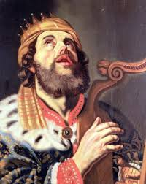
David

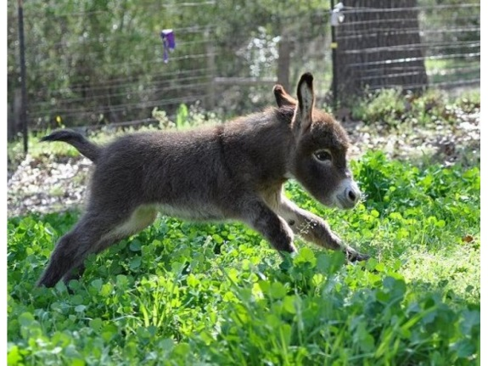
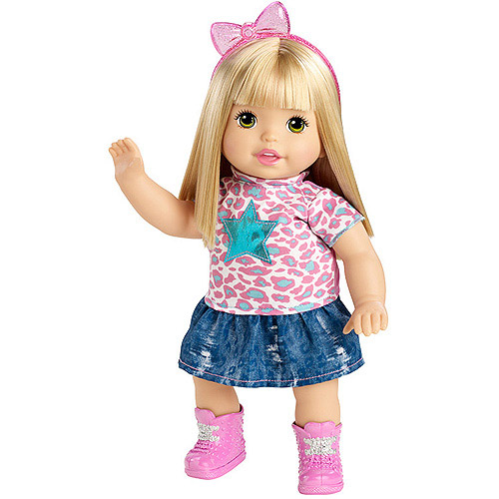
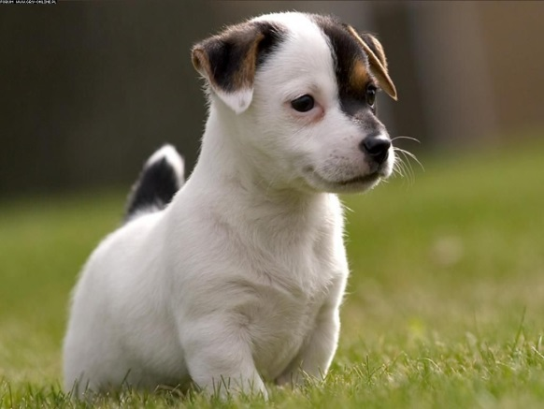
______________________________________________________________
_____________________________________________________

Dog

________________________________________________________________________________________________________________
Doll

____________________________________________________________________________________________________________________________________
Donkey

__________________________________________________________________________________________________________

