Ee

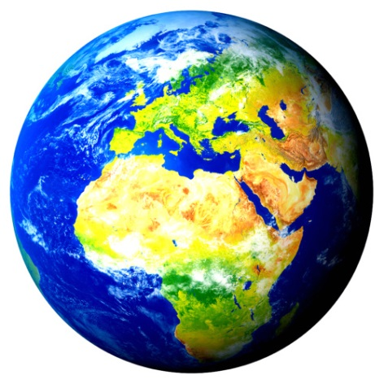
Earth

______________________________________________________________
_____________________________________________________

Egg

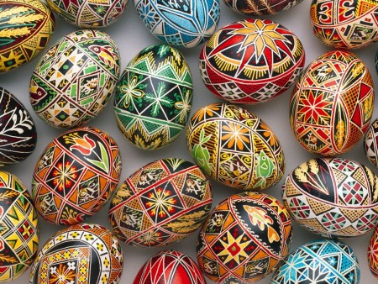

______________________________________________________________________________________________

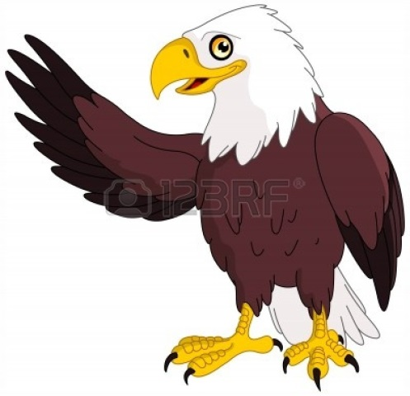
Eagle

____________________________________________________________________________________________________________________

