Ff


Family

______________________________________________________________
_____________________________________________________

Father

__________________________________________________________________________________________________________________________
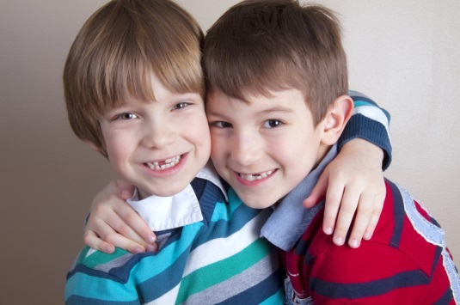
Friend

________________________________________________________________________________________________________________________
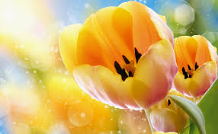
Flower

__________________________________________________________________________________________________________________________________

Fish





