Gg

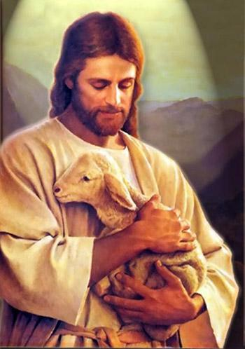
God

______________________________________________________________
_____________________________________________________

Girl



__________________________________________________________________________________________________________

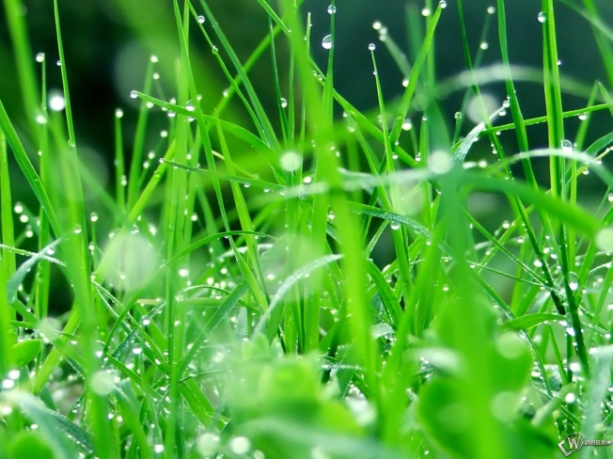
Grass

____________________________________________________________________________________________________________

