Hh


Heaven

______________________________________________________________
_____________________________________________________

House / home

________________________________________________________________________________________________________________________________________________________________________________________________________________________________________________

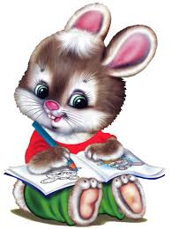
Hare

______________________________________________________________________________________________________________________________

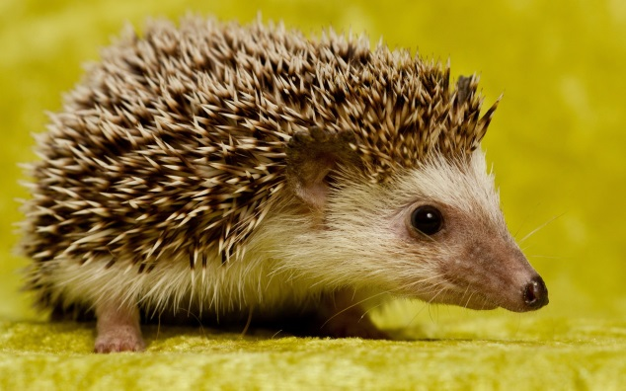
Hedgehog

____________________________________________________________________________________________________________

