Ii

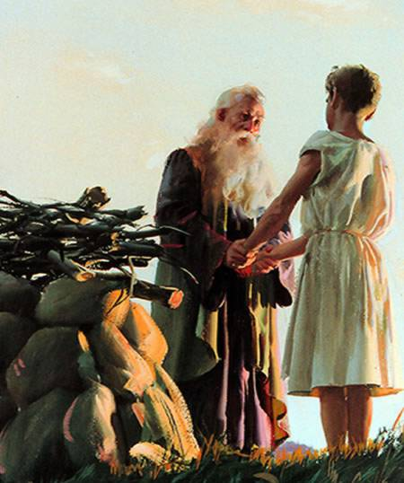
Isaak

___________________________________________________________

____________________________________________________

Ice-cream







