Jj

Jesus



______________________________________________________________

_____________________________________________________

Juice

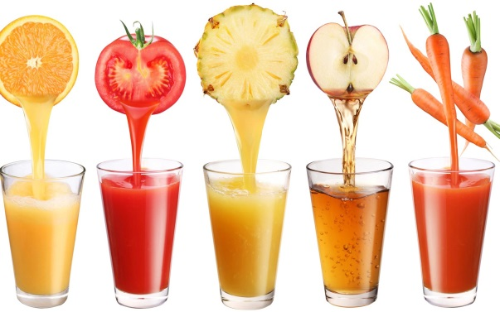

______________________________________________________
______________________________________________________

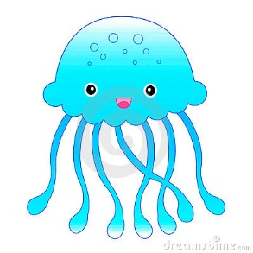
Jelly-fish

__________________________________________________________
__________________________________________________________

