Kk


Key

______________________________________________________________
_____________________________________________________
Kid



______________________________________
_______________________________________
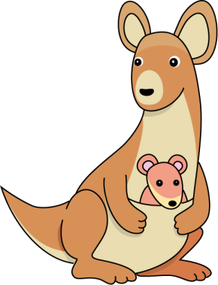
Kangaroo

______________________________________
______________________________________
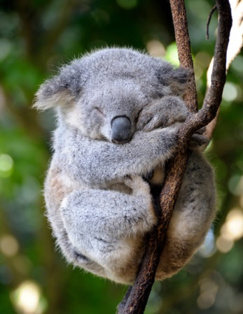
Koala

______________________________________
______________________________________
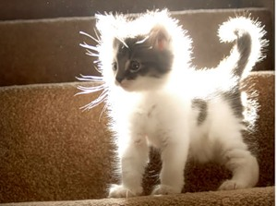
Kitten

______________________________________
______________________________________

