Ll

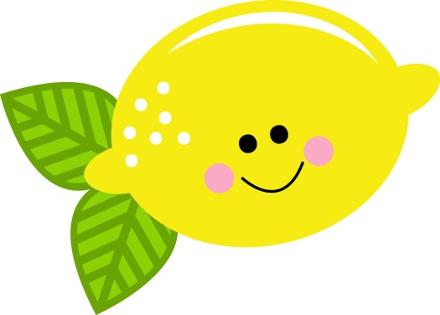
Lemon

______________________________________________________________
_____________________________________________________
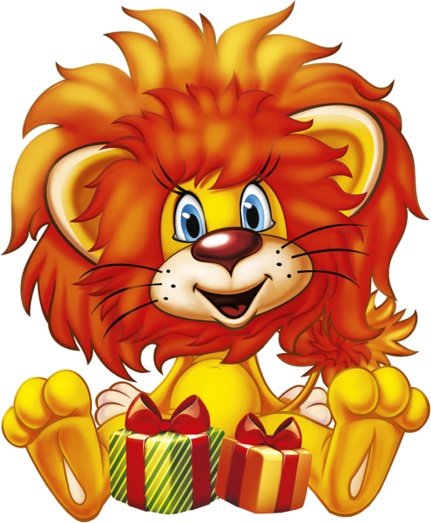
Lion

_________________________________
_________________________________

Leaf

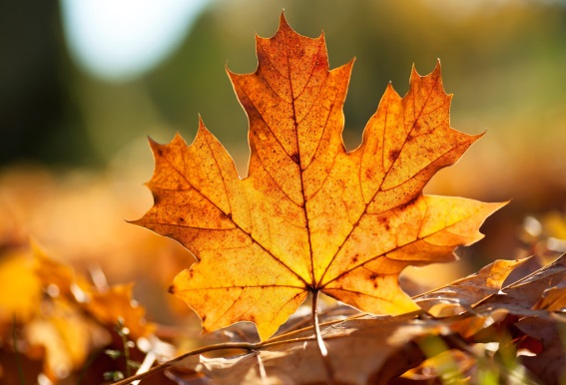

____________________________________________________
___________________________________________________
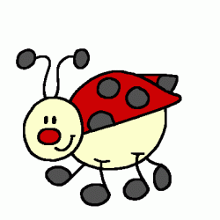
Ladybug

____________________________________________________
___________________________________________________

