Mm


Mother

______________________________________________________________
_____________________________________________________
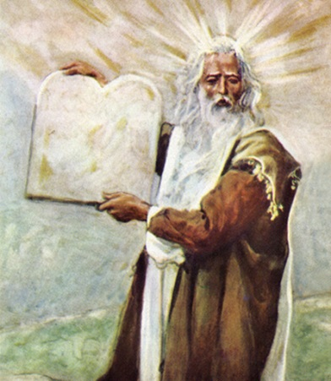
Moses

______________________________________________________________
_____________________________________________________
Mushroom

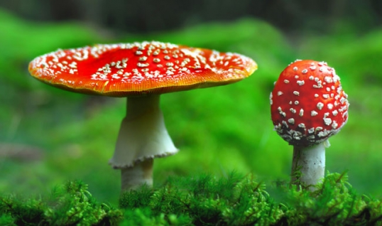

______________________________________________________________
_____________________________________________________
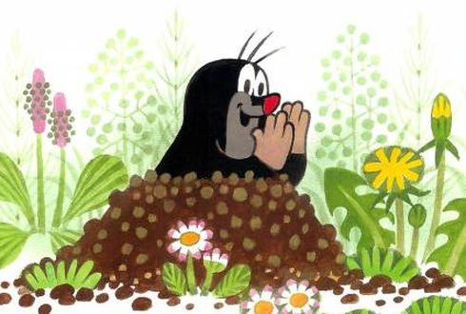
Mole

______________________________________________________________
_____________________________________________________
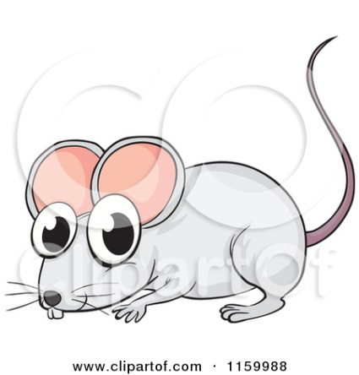
Mouse

______________________________________________________________
_____________________________________________________

